


No6

Demonstrate an in depth approaches to solving the problems during the practicum experience
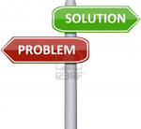



Define problem-solving approach.
What is problem?
Various philosophers have struggled to define what exactly a problem is, and in the Western tradition, some of the more prominent thinkers have had to rely upon other philosophical concepts. One view is that problems consist of a disconnect between one's free will and an objective reality. The problem here is that the objective reality in which we all live, and in which we all must participate, does not correspond with said free will. Some philosophers, as a result, affect problematization to best speak about problems.

Problem-solving approach?
Problem-solving approach in nursing...
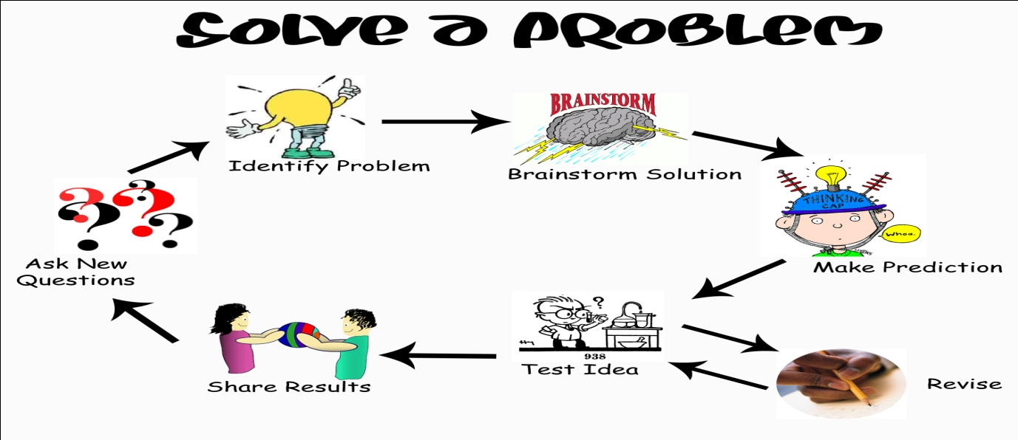
In nursing a conceptual framework that incorporates the overt physical needs of a patient with covert psychological emotional and social needs. It provides a model for caring for the whole person as an individual, not as an example of a disease or a medical diagnosis. Nursing is defined within this model as a problem-solving process. The patient is viewed as a person who is in an impaired state, less than usually able to perform self-care activities. Nursing problems are conditions experienced by the patient or the patient's family for which the nurse may provide professional service. The nurse makes a nursing diagnosis that identifies the impaired state and determines the care needed to augment the patient's ability to perform self-care. The requirements for care are classified in four levels: care given to sustain life is sustenal care; care given to assist the patient in self-care is remedial care; care that helps the patient develop new skills and goals in self-care is restorative care; and care given to guide the patient to a level of self-help beyond the normal level is preventive care. The approach identifies 21 nursing problems and sorts them into four groups: problems relating to comfort, hygiene, and safety; physiologic balance; psychological and social factors; and sociologic and community factors.

Seven Steps for Effective Problem Solving in the Workplace
People tend to do three things when faced with a problem: they get afraid or uncomfortable and wish it would go away; they feel that they have to come up with an answer and it has to be the right answer; and they look for someone to blame. Being faced with a problem becomes a problem.
And that's a problem because, in fact, there are always going to be problems!
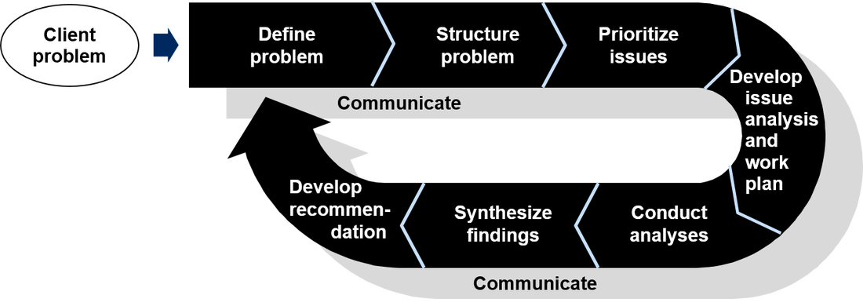

1. Identify the issues.
Here are seven-steps for an effective problem-solving process
1. Identify the issues
- Be clear about what the problem is.
- Remember that different people might have different views of what the issues are.
- Separate the listing of issues from the identification of interests (that's the next step!).
- Understand everyone's interests.
- This is a critical step that is usually missing.
- Interests are the needs that you want satisfied by any given solution. We often ignore our true interests as we become attached to one particular solution.
- The best solution is the one that satisfies everyone's interests.
- This is the time for active listening. Put down your differences for awhile and listen to each other with the intention to understand.
- Separate the naming of interests from the listing of solutions.
- List the possible solutions (options)
- This is the time to do some brainstorming. There may be lots of room for creativity.
- Separate the listing of options from the evaluation of the options.
- Evaluate the options.
- What are the pluses and minuses? Honestly!
- Separate the evaluation of options from the selection of options.
5. Select an option or options.
- What's the best option, in the balance?
- Is there a way to "bundle" a number of options together for a more satisfactory solution?



6. Document the agreement(s).
- Don't rely on memory.
- Writing it down will help you think through all the details and implications.



7. Agree on contingencies, monitoring, and evaluation.

- Conditions may change. Make contingency agreements about foreseeable future circumstances (If-then!).
- How will you monitor compliance and follow-through?
- Create opportunities to evaluate the agreements and their implementation. ("Let's try it this way for three months and then look at it.")
Problem Solving and the Nursing Process
- Burns and Grove define problem solving as the systematic identification of a problem, determination of goals relating to the problem, identification and possible approaches to achieve these goals, implementation of selected approaches, and evaluation of goal achievement.
- Lipe and Beasley characterize problem solving as a systematic approach resulting in the formation of solutions which involves the identification of the root problem through analysis.
- Notably, problem solving is used in various situations, such as, deciding which is the best route to take to work, deciding where to live or, clinically, how to position a patient with a fractured hip.
Table 1: Comparison of the Problem Solving Process and Nursing Process
Problem Solving Process | Nursing Process
Encounter problem | Assess
Analyze data to specific problem | Outcome identification
Determine plan of action to resolve problem | Plan
Execute action plan | Implement
Evaluate plan for effectiveness in problem resolution | Evaluate
Nursing Process
- Assessment:
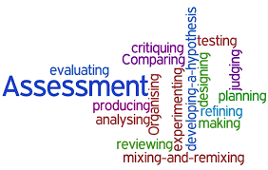
This involves the collection and interpretation of data to be used in developing a nursing diagnosis. This would include an assessment of the nurse’s patients with a focus on the problems that caused their hospital admissions. For example if they were admitted for myocardial infarction, they should be checked for chest pain or dyspnea.

- Diagnosis:
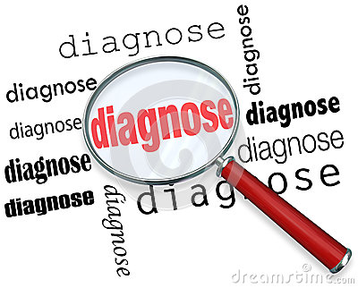
This step is the process of identifying and classifying data collection during assessment in order to develop the plan of care. Accepted nursing diagnosis came from the North American Nursing Diagnosis Association International (NANDA-I). A nursing diagnosis sets the stage for determining patient outcomes. The Association of preoperative Registered Nurses in the Preoperative Nursing Data Sets has identified desired patient outcomes.

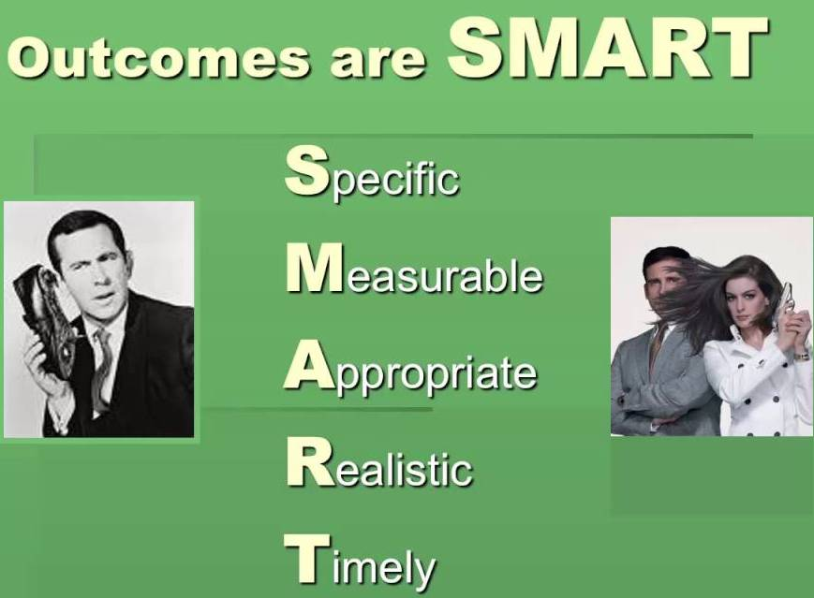
- Outcome identification:
Once the nursing diagnosis is determined
the preoperative nurse identifies the
desired outcome. The outcome is
measureable and provides direction for
outlining a plan of care.
- Plan:
After collecting and interpreting the data, identifying the nursing diagnosis and desired outcome a plan of care is developed and communicated to the team.


- Implementation :
Put the plan into action, in other words, perform the nursing activities and interventions and respond with critical thinking. This step is where the standards, guidelines and best practices are implemented.
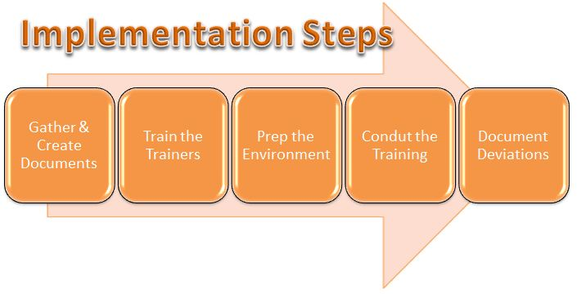

- Evaluation:
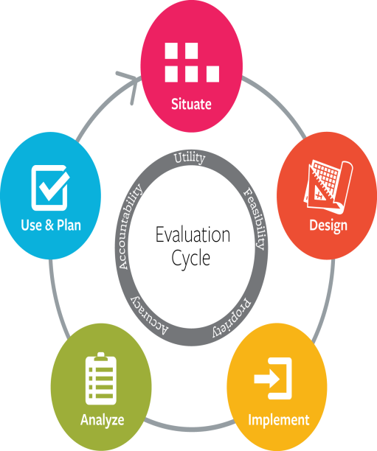


This entails checking, observing and appraising the results of interventions taken during the implementation phase.

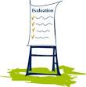
Discuss Decision-making exercise
- Decision-making exercise.
- You are allocated to work with a registered nurse (RN) and a healthcare assistant in providing rehabilitation care to a group of 10 elderly people with complex care needs based on a mixture of mental and physical health problems. The RN managed and directed the care during the shift.
- Describe the RN’s approach to organizing priorities in care giving during the shift.

- Under what influence or on what basis did he/she
make decisions (try to obtain this information
through reflective discussion at the end of the shift).
- Did you experience any changes in decisions over
the period of the shift and what do you think
influenced these changes.
- Decide how you could record what you had learned
so that you could explain your understanding of the
RN’s decision making to another learner/peer
group of learners.
CLINICAL DECISION MAKING
When attempting to describe decisions, the starting point should be some form of conceptual framework or model (McGrew and Wilson 1982). There are numerous models used to interpret and explain the process of clinical reasoning and the diversity of explanation has often masked common themes between them. There is also debate about how best to achieve a compromise or ‘middle ground’ between the various theories that are espoused (Buckingham and Adams 2000a, Harbison 2001, Thompson 1999).
Information-processing model
Information-processing model These principles are based on information-processing theory (Fonteyn and Ritter 2000). A key assumption of this theory is that the decision-maker stores relevant information in his or her memory and that effective decision- making or problem solving occurs when the problem solver retrieves information from both short- and long-term memory .

NURSES’ CLINICAL DECISIONS:
Clinical decisions, with examples that were derived from interviews with, and observation of, acute and primary care nurses. These decisions represent core choices that are only part of the architecture of the decision making context for applying research knowledge. Nurses described several other elements of their clinical decisions and decision making processes.
Decision types and clinical questions/choices expressed by acute and primary care nurses.
NURSES’ CLINICAL DECISIONS:
Frequency of decision making the number and types of decisions faced by nurses are related to the work environment, perceptions of their clinical role, operational autonomy, and the degree to which they see themselves as active and influential decision makers. Nurses working on a busy medical admissions unit admitting 50 patients per day face a different set of decision challenges compared with health visitors (HVs) or public health nurses, who may see 10 patients per day. Consider the extent to which judgment and choices feature in this HV’s consultation.
Three elements of decisional complexity that permeated nurses’ accounts of their decisions are described below.
- Decisional complexity
Time limited decision making activity.
Nurses described situations in which rapid decisions were expected (a phenomenon known as implied response time). Consequently, opportunities for seeking information beyond what was readily available were perceived as severely restricted. Limited time was a primary reason for the “separation” of day to day decision making from information seeking and appraisal. Despite these constraints on information use, some nurses felt that as their expertise developed, they managed to reduce contact time with patients by virtue of having to spend less time seeking information to reduce uncertainty in decision making. Decision related information seeking was associated with novice rather than expert performance.
- Decisional complexity
Multiple and diverse decision goals.

The stepwise nature of information gathering and decision making in patient encounters, as well as the need to foster patient perceptions of trust and credibility in the nurse, meant that decisions often had multiple and conflicting decision goals. For example, one HV described the need to build confidence in a young mother, leading her to sanction weaning at 12 weeks rather than (for her) the more optimal 16 weeks (current best evidence suggests that the optimum time for weaning is 24 weeks).
- Conflicting decision elements.
As well as making decisions more complex, conflict can also simplify decisions. The following example of conflict in nurse-doctor power relations demonstrates this point:


CONCLUSION...
Nurses are increasingly regarded as key decision makers within the healthcare team. They are also expected to use the best available evidence in their judgments and decisions. The prescriptive model of evidence-based decision making—and the search-appraise-implement process that accompanies it—is an active process. Clinicians who want to implement research in clinical settings sometimes forget that active information seeking is only one of several possible responses to the irreducible uncertainties of clinical practice. In fact, observation of nurses in practice suggests that when “search and appraise” information behaviour occurs at all, nurses are far more likely to view colleagues (“human” sources of information) as useful and accessible sources of information than research in any form. Colleagues are perceived as delivering context specific, clinically relevant information that takes into account the needs of the judgment or decision situation and requires minimal critical appraisal; and they are time efficient. We would argue that this implies a degree of “fit” between the decision task and the information provided, although not necessarily the provision of high quality (i.e. reliable or valid) information. Moreover, long standing theoretical frameworks explain this lack of fit between traditional evidence-based sources of research information and the decisions that nurses’ fac

